Dexal Group of Companies
Revenue Trends, Product Mix, and Category Performance Analysis (2023) Analysis and Findings

UMAR MUSTAPHA
Umustapha874@gmail.com

Introduction
Descriptive Analysis of the Dexal Group Dataset
The dataset captures 2023 sales transaction data for Dexal Group of Companies, a grocery-focused retail business operating across 12 cities in the United States. It tracks salesperson, customer, state, product name, product category, region, order date, quantity, unit price, and revenue. This report approaches the same underlying transactional dataset used in an earlier project from a different analytical angle, focusing on monthly revenue trend, product-level performance, and category composition rather than customer concentration and individual salesperson deep dives.
Business Composition
The dataset spans five active salespersons (Nancy Freehafer, Anne Larsen, Andrew Cencini, Mariya Sergienko, and Laura Giussani), three leading customer accounts (Company D, Company H, and Company BB), ten distinct products spanning three product categories (Beverages, Sauces, and Jams & Preserves), and four sales regions (North, East, South, and West) across 12 cities.
Story of the Data
This dataset tells the story of a full calendar year of grocery sales, where revenue climbs and dips with clear seasonal rhythm, a small number of products carry a disproportionate share of total sales, and one product category dominates the entire portfolio. Where the earlier analysis of this dataset focused on who was selling and to whom, this version focuses on what was selling, when, and in what mix, questions that only become visible once the same numbers are cut a different way.
Industry Type
The dataset belongs to the Grocery Retail industry, with a specific focus on monthly revenue trend analysis, product performance, and category mix management.
It is relevant to the following areas:
- Retail Sales Trend Analysis
- Product Portfolio Management
- Category Performance and Inventory Planning
- Regional Revenue Distribution
- Seasonal Demand Forecasting
Project Stakeholders
Key stakeholders include Dexal Group's sales and merchandising leadership, inventory and supply chain planners who need to anticipate seasonal demand, category managers overseeing the Beverages, Sauces, and Jams & Preserves lines, and regional managers responsible for North, East, South, and West performance.
Variable Classification
Time and transaction variables
- Order Date
- Month
Sales team and customer variables
- Salesperson
- Customer Name
Geographic variables
- State
- City
- Region
Product variables
- Product Name
- Category
Performance variables
- Quantity
- Unit Price
- Revenue
Potential Analysis
- How does monthly revenue trend across the calendar year, and where do the sharpest peaks and dips occur?
- Which products generate the highest total revenue, and how concentrated is that contribution?
- How is total revenue distributed across the three product categories?
- Which cities and states contribute the most to overall revenue?
- Which salespersons and customers drive the largest share of total sales?
- How does regional revenue distribution compare across North, East, South, and West?
- What does the relationship between maximum quantity and maximum unit price suggest about high-value versus high-volume transactions?
Analysis of Key Relationships
Monthly Revenue Trend
Observations
- Revenue opened the year at $33K in January, dipped to $20K in February, the lowest point of the first half of the year.
- Revenue climbed steadily from March ($31K) through June ($56K), the strongest month of the first half.
- July dropped sharply to $27K, before rebuilding through August ($30K) and September ($32K).
- October surged to $53K, the second-highest month of the year, before falling back to $32K in November.
- December closed the year at $67K, the single highest-revenue month across the entire year.
Insights
- The year shows a clear two-peak pattern, a mid-year peak in June and a year-end peak in December, both followed immediately by a pullback the following month (July and, implicitly, into the next year). This rhythm is consistent enough to actively plan inventory and staffing around rather than treat as unpredictable.
- February's position as the weakest month of the year, alongside a smaller dip in November, suggests these two months consistently underperform and would benefit from a dedicated promotional push to smooth out the annual revenue curve.
Revenue by Salesperson
Observations
- Nancy Freehafer generated the highest revenue of any salesperson at 104K.
- Anne Larsen followed closely at 94K.
- Andrew Cencini generated 67K, roughly two-thirds of Nancy Freehafer's total.
- Mariya Sergienko and Laura Giussani generated 42K and 41K respectively, forming a clear lower tier well below the top three.
Insights
- The gap between the top two performers (104K and 94K) and the bottom two (42K and 41K) is more than double, indicating a meaningful performance split within a five-person sales team worth addressing through coaching or account rebalancing.
- Nancy Freehafer and Anne Larsen together account for close to half of total company revenue between just two people, making their retention and continued performance disproportionately important to the business.
Revenue by Product Name
Observations
- Coffee is the top-performing product at 75K, the single highest revenue generator in the portfolio.
- Curry follows closely at 69K.
- Marmalade and Mozzarella form a clear second tier at 41K and 33K respectively.
- Crab, Beer, Chocolate, Clam, Cajun, and Olive products round out the list, ranging from 25K down to 13K, each contributing a comparatively small share of total product revenue.
Insights
- Coffee and Curry together generate more revenue than the bottom six products combined, making them the two highest-priority items for stocking, promotion, and supply chain reliability.
- The steep drop-off after the top four products (75K, 69K, 41K, 33K) down to the remaining six (25K and below) suggests the portfolio has a small core of essential products surrounded by a longer tail of lower-impact items.
Revenue by Customer Name
Observations
- Company D is the leading customer at 67K in revenue.
- Company H follows at 50K.
- Company BB generates 44K, the smallest of the three named top customers.
Insights
- With only three customers explicitly named and visible on this chart, customer concentration remains a relevant risk, losing any one of these three accounts would represent a meaningful hit to total revenue.
- The relatively tight spread between Company H (50K) and Company BB (44K) suggests these two accounts are performing at a broadly similar level, while Company D stands out as the clear top account.
Revenue by Category
Observations
- Beverages account for 47.84% of total revenue, close to half of all sales.
- Sauces account for 29.85%.
- Jams, Preserves account for the smallest share at 22.3%.
Insights
- Beverages functioning as nearly half of total revenue makes it the single highest-risk category to ever run short on, any supply disruption here would have an outsized impact on overall performance.
- Jams, Preserves' comparatively smaller share does not necessarily mean underperformance, but it does mark this category as the one with the most room for growth if targeted promotion or expanded product range were introduced.
Revenue by Region
Observations
- North generated the highest regional revenue at 141.68K.
- East followed at 108.28K.
- South generated 93.86K.
- West generated the lowest regional revenue at 91.25K.
Insights
- North's lead over West, roughly 50K, or more than 55% higher, confirms a consistent regional imbalance that shows up regardless of how this dataset is sliced or visualized.
- South and West's closely matched totals (93.86K and 91.25K) suggest these two regions may share similar underlying market conditions or customer bases, worth investigating as a pair rather than separately.
Key Metrics Overview
Observations
- Total revenue for the year reached 435.07K.
- Maximum quantity in a single transaction reached 100 units.
- Total quantity sold across the year reached approximately 21K units, against a visualized range of 0 to 41K.
- The business operated across 12 distinct cities.
- The highest unit price recorded for any single product was 81.
Insights
- The gap between the maximum quantity recorded (100 units) and the overall total (21K units) suggests that most individual transactions are modest in size, with occasional large bulk orders standing out as exceptions rather than the norm.
- A maximum unit price of 81 alongside a maximum quantity of 100 raises the question of whether the highest-value transactions come from high-price, low-quantity orders or high-quantity, lower-price bulk orders, worth a dedicated cross-tabulation in future analysis.
Key Insights
- The Year Follows a Clear Two-Peak Rhythm: Revenue peaks in June (56K) and again in December (67K), each followed by an immediate pullback, a pattern reliable enough to actively plan around.
- A Small Group of Salespersons and Products Carries the Business: Nancy Freehafer and Anne Larsen together generate close to half of total revenue, while Coffee and Curry alone outproduce the bottom six products combined.
- Beverages Dominate the Category Mix: At 47.84% of total revenue, Beverages represent close to half the business, making it the single most important category to protect from supply disruption.
- Regional Performance Is Consistently Imbalanced: North leads every other region by a wide margin (141.68K versus West's 91.25K), a pattern that persists regardless of how the underlying dataset is visualized.
- February and November Are Consistent Soft Spots: Both months underperform relative to the months around them, marking them as specific, targetable opportunities for promotional activity.
- Customer Concentration Remains a Real Consideration: With only three customers explicitly visible on the leading accounts chart, the loss of any one, particularly Company D, would represent a meaningful revenue impact.
Data Visualizations and Charts
POWER BI ANALYSIS
Dashboard
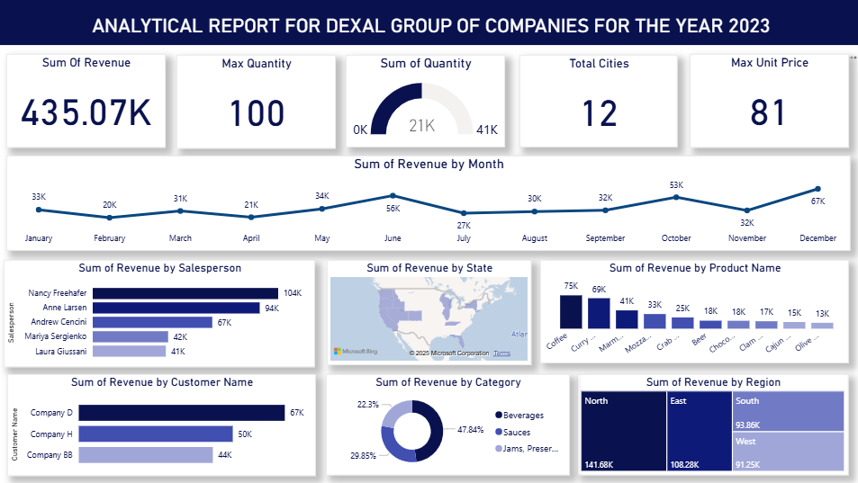
The dashboard consolidates five KPI cards (Sum of Revenue, Max Quantity, Sum of Quantity, Total Cities, Max Unit Price) with seven core visualizations covering monthly trend, salesperson performance, state-level geography, product performance, customer performance, category mix, and regional distribution.
KPI Summary
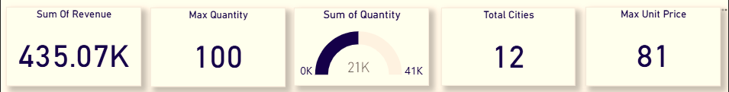
Sum of Revenue: 435.07K. Max Quantity: 100. Sum of Quantity: 21K (of a 0 to 41K range). Total Cities: 12. Max Unit Price: 81.
Sum of Revenue by Month
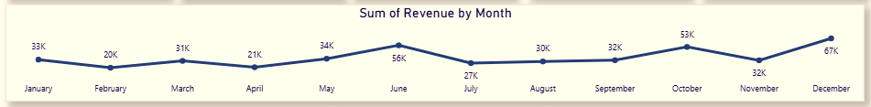
Line chart tracking monthly revenue across 2023. Revenue opens at 33K in January, dips to a first-half low of 20K in February, climbs to a mid-year peak of 56K in June, dips again to 27K in July, and closes the year at its highest point, 67K in December.
Sum of Revenue by Salesperson
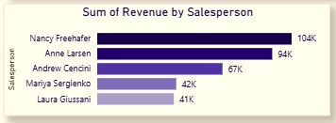
Bar chart ranking salespersons by total revenue. Nancy Freehafer leads at 104K, followed by Anne Larsen (94K), Andrew Cencini (67K), Mariya Sergienko (42K), and Laura Giussani (41K).
Sum of Revenue by State
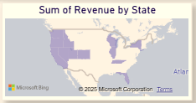
Filled map showing revenue concentration across states, spanning the 12 cities tracked in the dataset, with darker shading indicating higher revenue concentration.
Sum of Revenue by Product Name
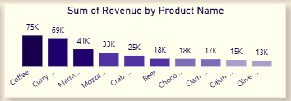
Column chart ranking the top ten products by revenue. Coffee leads at 75K, followed by Curry (69K), Marmalade (41K), Mozzarella (33K), Crab (25K), Beer and Chocolate (18K each), Clam (17K), Cajun (15K), and Olive (13K).
Sum of Revenue by Customer Name
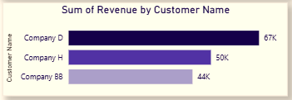
Bar chart ranking top customers by revenue. Company D leads at 67K, followed by Company H (50K) and Company BB (44K).
Sum of Revenue by Category
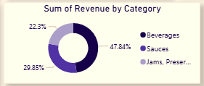
Donut chart showing revenue share by product category. Beverages lead at 47.84%, followed by Sauces (29.85%) and Jams, Preserves (22.3%).
Sum of Revenue by Region
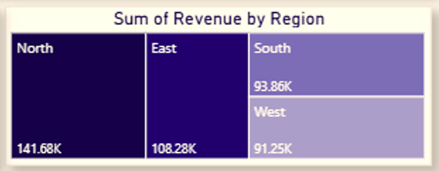
Treemap comparing total revenue by region. North leads at 141.68K, followed by East (108.28K), South (93.86K), and West (91.25K).
Dashboard Summary
Power BI dashboard representing total revenue, quantity, city count, and maximum unit price, alongside monthly revenue trend, salesperson performance, state-level geography, product performance, customer performance, category composition, and regional revenue distribution.
Chapter Five: General Observations and Recommendations
Observations
- Revenue followed a clear seasonal pattern across 2023, with mid-year (June) and year-end (December) peaks, each followed by an immediate pullback the following month.
- February and November consistently underperformed relative to surrounding months, appearing as the two clearest soft spots in the annual trend.
- Salesperson performance was uneven, with Nancy Freehafer and Anne Larsen together generating close to half of total company revenue.
- Product performance was concentrated at the top, with Coffee and Curry alone outproducing the six lowest-performing products combined.
- Beverages dominated category-level revenue at 47.84%, close to half of all sales, followed by Sauces and Jams & Preserves.
- Regional performance remained consistently imbalanced, with North outperforming every other region, a pattern that held true across both this dashboard and the earlier version built on the same dataset.
- Customer concentration remained visible at the top of the account list, with only three customers explicitly represented on the leading accounts chart.
Recommendations
- Use the consistent June and December revenue peaks to plan staffing, inventory, and marketing investment ahead of these two months each year.
- Introduce targeted promotional campaigns specifically for February and November to smooth out the two clearest dips in the annual revenue curve.
- Pair top-performing salespersons like Nancy Freehafer and Anne Larsen with lower performers like Mariya Sergienko and Laura Giussani through mentorship or shared account strategy.
- Prioritize Coffee and Curry for consistent stocking and supply chain reliability, given their outsized share of total product revenue.
- Protect Beverages category supply chains specifically, given that a disruption here would affect close to half of total company revenue.
- Continue strengthening North's proven regional approach while investigating whether specific practices from North can be adapted for West, the lowest-performing region.
- Deepen the customer base beyond the current top three accounts to reduce dependency risk on Company D, Company H, and Company BB.
Conclusion
This analysis, built on the same underlying dataset as an earlier Sales Performance project but restructured around monthly trend, product mix, and category composition, confirms that Dexal Group's 2023 performance follows a consistent and identifiable shape. Total revenue reached 435.07K across 12 cities, but that total was driven by a clear seasonal rhythm, a concentrated core of top products and top salespersons, and a category mix leaning heavily on Beverages.
Monthly trend analysis revealed a two-peak year, June and December, each followed by an immediate dip, a pattern specific and repeatable enough to build planning around. Product and category analysis showed the same concentration pattern seen elsewhere in this dataset, a small core of high performers (Coffee, Curry, Beverages) carrying a disproportionate share of results. Regional performance reaffirmed North's consistent lead over the other three regions, regardless of how the dataset was cut or visualized.
The clearest opportunity sitting inside this version of the dataset is the calendar itself, using the reliable June and December peaks to plan proactively, and treating February and November as specific, addressable dips rather than unavoidable slow periods.
Limitations of the Study
- Shared Dataset with a Prior Project: This analysis is built on the same underlying transactional data as an earlier Sales Performance project, meaning findings around salesperson and regional performance overlap rather than represent an entirely independent dataset.
- Limited Geographic Detail: The Sum of Revenue by State map shows relative concentration but does not display exact state-level figures, limiting precision in geographic recommendations.
- Partial Product Visibility: Only ten products are shown on the product performance chart, meaning the full product catalog and its complete revenue distribution is not entirely visible in this dashboard.
- No Cost or Margin Data: The dataset provides revenue, quantity, and unit price, but not cost or profit margin, limiting the ability to assess true profitability by product, category, or region.
Suggestions for Future Work
- Cross-Tabulate Quantity and Unit Price: Investigate whether the business's highest-value transactions come from high-price, low-quantity orders or high-quantity, low-price bulk orders.
- State-Level Data Labels: Add explicit revenue figures to the state map to allow precise geographic comparison rather than relative shading alone.
- Full Product Catalog Analysis: Extend the product performance view beyond the current top ten to capture the complete revenue distribution across the full catalog.
- Margin and Profitability Analysis: Incorporate cost data to assess true profitability by product, category, and region, rather than revenue alone.
- Cross-Reference with the Prior Sales Performance Project: Since both analyses share the same dataset, a combined view merging customer, salesperson, product, and time-based findings could produce a more complete single report than either version alone.

